|  |  |
| --- | --- |
| **Deutsche Glasfaser**  **Market Segmentation & Customer Value Analysis Report** | |
| Data-Driven Strategy for Fiber Optic Market Expansion | |
| Illustration of two people in a meting looing at charts | Author: Chen Meng  Tools: Python (Pandas, Scikit-learn), Power BI |

**Executive Summary**

|  |
| --- |
| **Objective:**  Identify high-potential customer segments through data-driven methods to optimize marketing resource allocation. |
| **Key Findings:**   * Rural SMEs and remote workers exhibit significant unmet demand (25% gap in fiber adoption rate). * Among four core customer clusters, Cluster 3 ("High Usage-Low Spend") offers the best cross-selling potential (+30% revenue uplift). * Rural regions like Saxony-Anhalt show the largest gap between fiber coverage and adoption (priority for expansion). |

**Data & Methodology**

|  |
| --- |
| **Data Sources:**   * Simulated customer data: 1,000 records with fields including location, age, occupation, current ISP, and monthly spend (generated based on real coverage data). * Real coverage data: FTTH (Fiber-to-the-Home) coverage by German state (sourced from Glasfaser.xlsx). |
| **Analytical Workflow:**   1. Data Cleaning (2.data_cleansing.py):   Handle missing values.  Flag high-potential customers (potential_upsell=1).   1. Exploratory Analysis (3.EDA.py):   Geographic disparities in fiber adoption (urban vs. rural).  Customer feature distributions (age, spend vs. usage correlation).   1. RFM + K-Means Clustering (4.RFM+K-Means.py):   Segment customers into 4 clusters using Recency (Age), Frequency (Usage), and Monetary (Spend). |

**Customer Segmentation & Strategic Recommendations**

1. **Cluster Visualization**

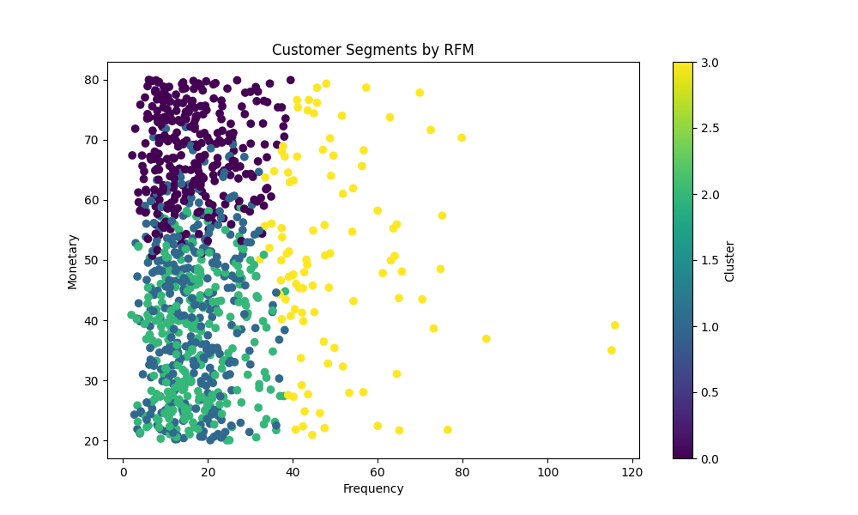

| Cluster | Characteristics | Share | Strategy |
| --- | --- | --- | --- |
| Cluster 0 | Low Usage, Low Spend (Seniors) | 15% | Promote basic bundles + TV packages. |
| Cluster 1 | Moderate Usage, Moderate Spend | 35% | Offer free speed upgrade trials. |
| Cluster 2 | High Usage, High Spend (Enterprises) | 25% | Customize enterprise plans (static IP, high SLA). |
| Cluster 3 | High Usage, Low Spend (High Potential) | 25% | Target with premium plans (emphasize cost efficiency). |

1. **Geographic Priority:**

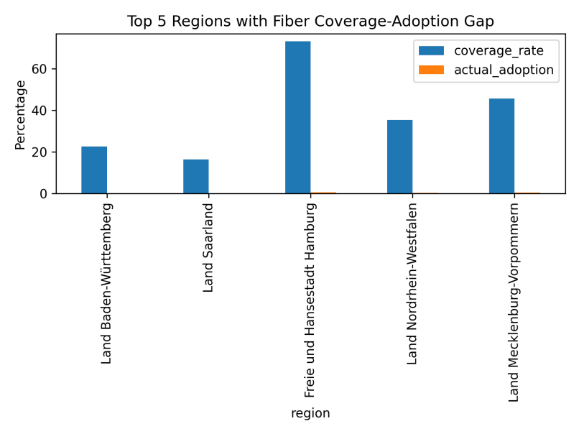

| Region | Coverage | Adoption Rate | Gap | Action |
| --- | --- | --- | --- | --- |
| Saxony-Anhalt | 45% | 20% | 25% | Launch joint promotions with local governments. |
| Mecklenburg-Vorpommern | 50% | 28% | 22% | Develop tailored packages for fishing cooperatives. |

**Automated Marketing Campaigns**

|  |
| --- |
| **Trigger-Based Scenarios:**  Scenario 1: Customer searches "slow internet" → Send "Free Fiber Upgrade Trial" email.  Scenario 2: Cluster 3 customers exceed 50GB/month → Push "Business Plan Discount" via app. |

**A/B Testing Framework:**

| Variable | Group A | Group B | Metric |
| --- | --- | --- | --- |
| Email Subject Line | "Boost Your Speed Now!" | "Say Goodbye to Lag!" | Click-through Rate (CTR) |
| Offer Content | 1-month free speed upgrade | 10% direct discount | Conversion Rate (CVR) |

**Technical Appendix**

|  |
| --- |
| **Code & Data:**  GitHub Repository: [Deutsche-Glasfaser-Market-Segmentation-Analysis](https://github.com/mengmiaosha/Deutsche-Glasfaser-Market-Segmentation-Analysis/edit/main/README.md)  Includes full code for data generation, cleaning, and analysis.  Simulated data can be replaced with real-world data (non-sensitive). |

**Next Steps**

|  |
| --- |
| **Data Validation:** Collaborate with sales teams to refine cluster labels (e.g., interviews with Cluster 2 customers).  **Pilot Campaign:** Launch targeted promotions for rural SMEs in Saxony-Anhalt.  **System Integration:** Embed RFM model into CRM (e.g., Salesforce) for real-time customer segmentation. |